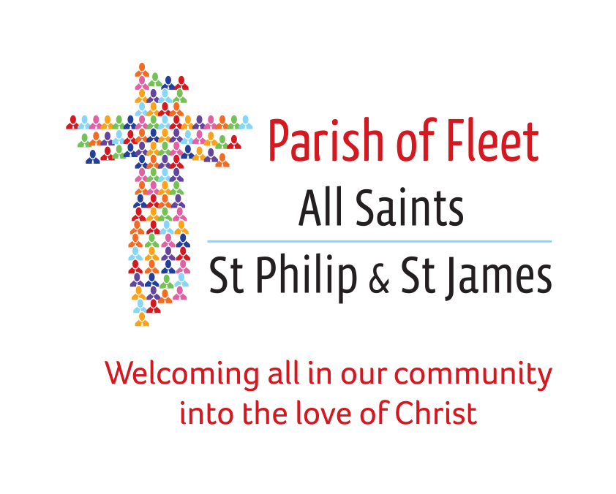

The Annual Parochial Church Meeting will be held on
Monday 19th October 2020 at 7.30pm via Zoom

A G E N D A

CHURCHWARDEN’S MEETING

- Opening prayers

- Apologies for absence

- Minutes of the last vestry meeting

- Matters arising therefrom if needed

- Election of Churchwardens

ANNUAL PAROCHIAL CHURCH MEETING

- Apologies for absence

- Minutes of last Annual Parochial Church Meeting
- Matters arising therefrom
- Election of PCC representatives
- Election of Deanery Synod representatives
- Presentation of annual accounts
- Review of annual reports (circulated prior to meeting)
- Electoral roll report
- Engagement of independent examiner
- Vicar’s Report

